ASSIGNMENT 02 LAB 03

QUESTION 01(CODE)

#include <iostream>

using namespace std;

int main ()

{

int a,b;

cout<<"Enter first integer \n";

cin>>a;

cout<<"Enter second integer "<<endl;

cin>>b;

if(a==b)

cout<<"Yes they are equal "<<endl;

else

cout<<"They are unequal "<<endl;

system("pause");

return 0 ;

}

QUESTION 01(OUTPUT) 01

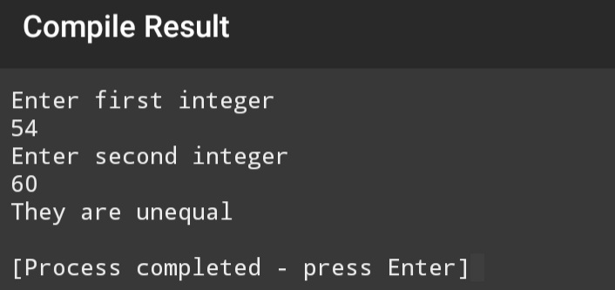

QUESTION 01(OUTPUT) 02

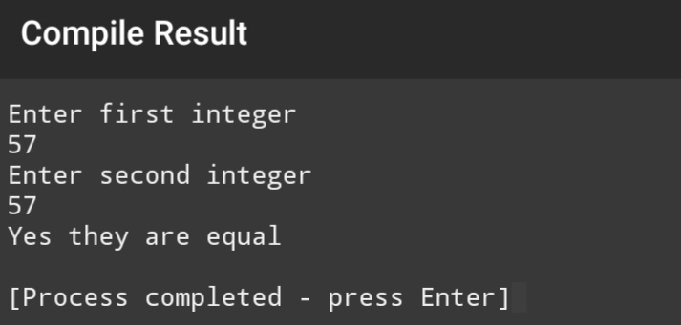

QUESTION 02(CODE)

#include <iostream>

using namespace std;

int main ()

{

float percentage;

cout<<"Enter the percentage:\n";

cin>>percentage;

if( percentage>=0 && percentage<=100 )

{

if( percentage>=90 )

cout<<"Your grade is A1:";

else if( percentage>=80 )

cout<<"Your grade is A:";

else if( percentage>=70 )

cout<<"Your grade is B:";

else if( percentage>=60 )

cout<<"Your grade is C:";

else if( percentage<60)

cout<<"You are fail!";

}

system("pause");

return 0 ;

}

QUESTION 02(OUTPUT) 01

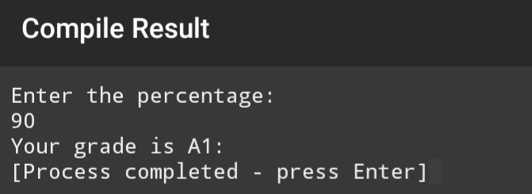

QUESTION 02(OUTPUT) 02

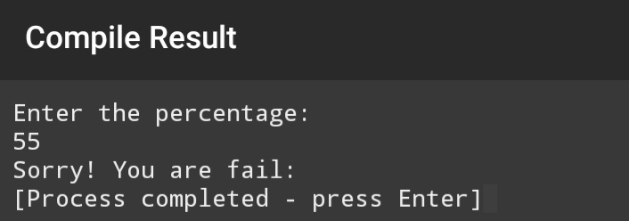

QUESTION 02(OUTPUT) 03

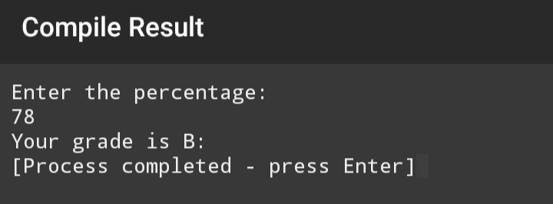

QUESTION 03(CODE)

#include<iostream>

using namespace std;

int main()

{

cout<<" MARKSHEET \n";

int sub1,sub2,sub3,sub4,sub5,obtained_marks,percentage;

cout << "enter the marks of sub1 \n";

cin>>sub1;

//each subject contain total marks 100:

cout << "enter the marks of sub2 \n";

cin>>sub2;

cout << "enter the marks of sub3 \n";

cin>>sub3;

cout << "enter the marks of sub4 \n";

cin>>sub4;

cout << "enter the marks of sub5 \n";

cin>>sub5;

cout<<"obtained_marks=";

obtained_marks=sub1+sub2+sub3+sub4+sub5;

cout<<obtained_marks<<endl;

cout<<"percentage=";

percentage=obtained_marks*100/500;

cout<<percentage<<endl;

if( percentage>=90 )

cout<<"Your grade is A1:";

else if( percentage>=80 )

cout<<"Your grade is A:";

else if( percentage>=70 )

cout<<"Your grade is B:";

else if( percentage>=60 )

cout<<"Your grade is C:";

else if( percentage<60)

cout<<"You are fail!";

return 0;

}

QUESTION 03(OUTPUT) 01

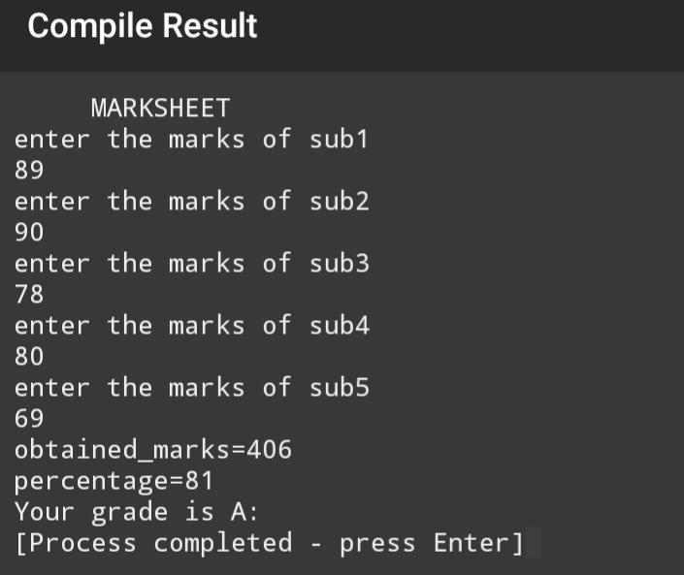

QUESTION 03(OUTPUT) 02

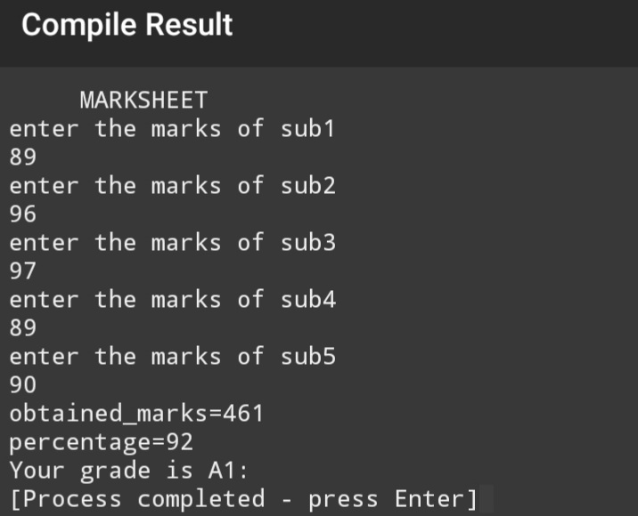

QUESTION 03(OUTPUT) 03

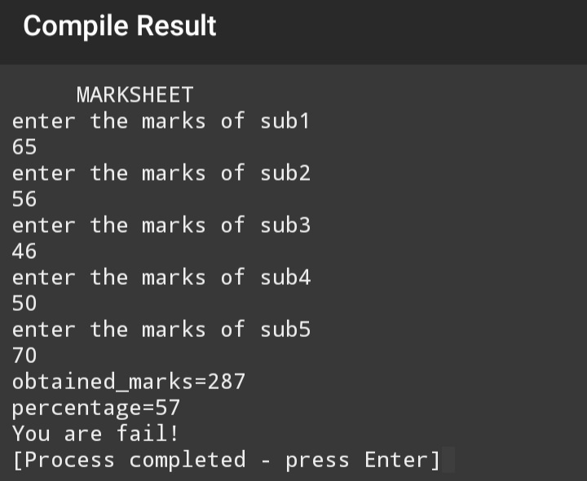

QUESTION 04(CODE)

#include <iostream>

using namespace std;

int main ()

{

int a;

cout<<"Enter an integer number:\n ";

cin>>a;

if(a/2 && a%2==0)

cout<<"It is an even number\n ";

else

cout<<"It is an odd number\n ";

system("pause");

return 0 ;

}

QUESTION 04(OUTPUT) 01

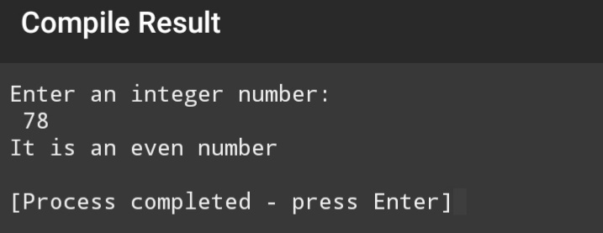

QUESTION 04(OUTPUT) 02

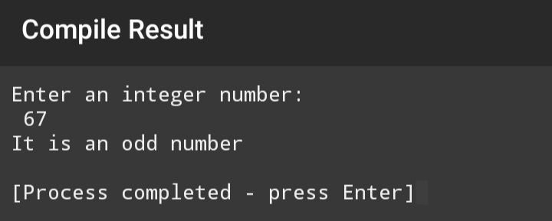

QUESTION 05(CODE)

#include <iostream>

using namespace std;

int main ()

{

int x;

cout<<"Enter a number: \n";

cin>>x;

if(x<0)

cout<<x<<" is a negative number:\n";

else if(x>0)

cout<<x<<" is a positive number:\n";

else if(x==0)

cout<<x<<" is a zero number:\n";

system("pause");

return 0 ;

}

QUESTION 05(OUTPUT) 01

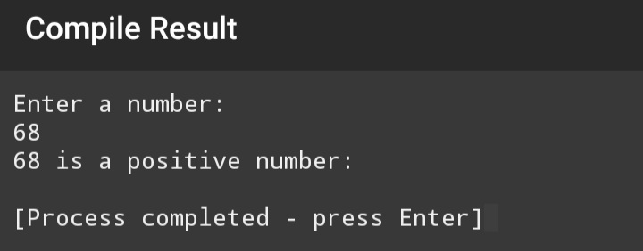

QUESTION 05(OUTPUT) 02

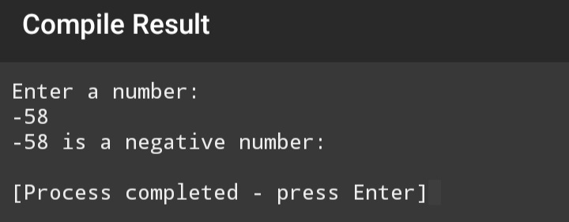

QUESTION 05(OUTPUT) 03

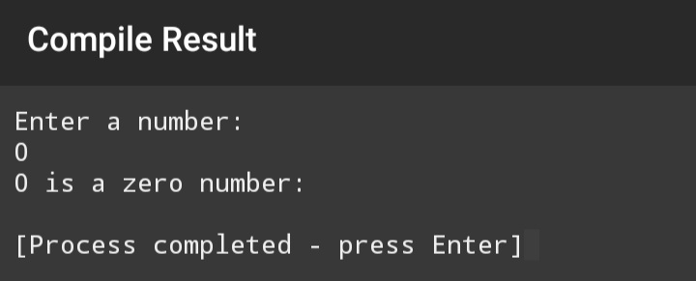

QUESTION 06(CODE)

#include <iostream>

using namespace std;

int main ()

{

int a;

cout<<"Enter a number of month in positive integer:\n";

cin>>a;

if(a==1)

cout<<"It is january:\n";

else if(a==2)

cout<<"It is febuary:\n";

else if(a==3)

cout<<"It is march:\n";

else if(a==4)

cout<<"It is april:\n";

else if(a==5)

cout<<"It is may:\n";

else if(a==6)

cout<<"It is june:\n";

else if(a==7)

cout<<"It is july:\n";

else if(a==8)

cout<<"It is agust:\n";

else if(a==9)

cout<<"It is septumber:\n";

else if(a==10)

cout<<"It is october:\n";

else if(a==11)

cout<<"It is november:\n";

else if(a==12)

cout<<"It is december:\n";

system("pause");

return 0 ;

}

QUESTION 06(OUTPUT) 01

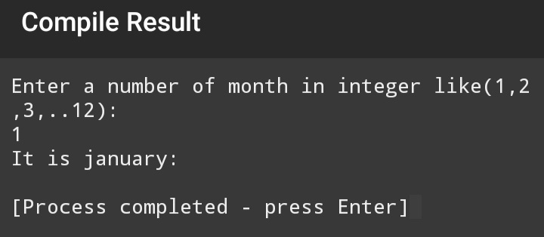

QUESTION 06(OUTPUT) 02

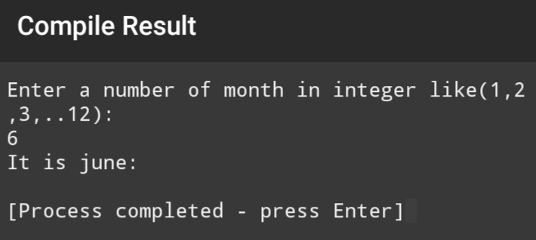

QUESTION 06(OUTPUT) 03

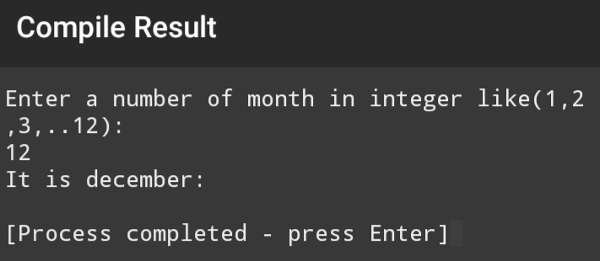

QUESTION 07(CODE)

#include<iostream>

using namespace std;

int main()

{

int x,y;

cout <<"Enter first number:\n";

cin>>x;

cout <<"Enter second number:\n";

cin>>y;

if(x>y)

cout <<"First number is greater than second:\n";

else if(y>x)

cout <<"Second number is greater than first:\n";

else if(x==y)

cout <<" Both numbers are equal:\n";

return 0;

}

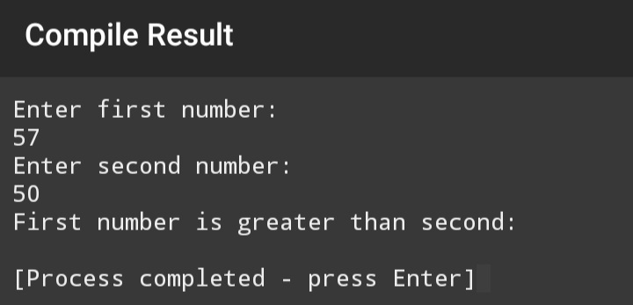QUESTION 07 (OUTPUT) 01

QUESTION 07(OUTPUT) 02

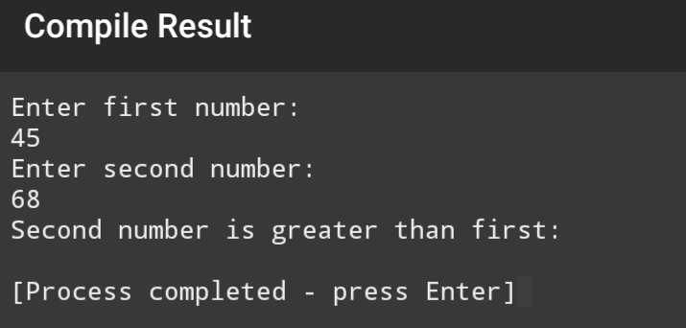

QUESTION 07(OUTPUT) 03

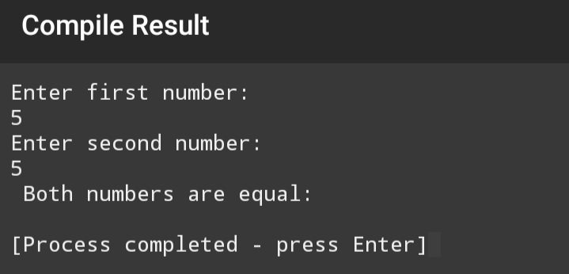

QUESTION 08(CODE)

#include <iostream>

using namespace std;

int main ()

{

int a,b,c;

cout<<"Enter first number:\n";

cin>>a;

cout<<"Enter second number:\n";

cin>>b;

cout<<"Enter third number:\n";

cin>>c;

if(a>b && a>c)

cout<<"First number is greatest:";

else if(b>a && b>c)

cout<<"Second number is greatest:";

else if(c>a && c>b)

cout<<"Third number is greatest:";

system("pause");

return 0 ;

}

QUESTION 08(OUTPUT) 01

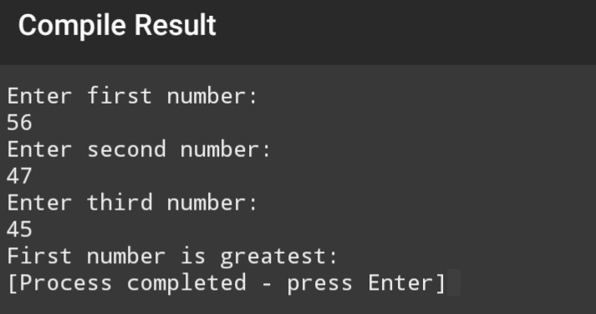

QUESTION 08(OUTPUT) 02

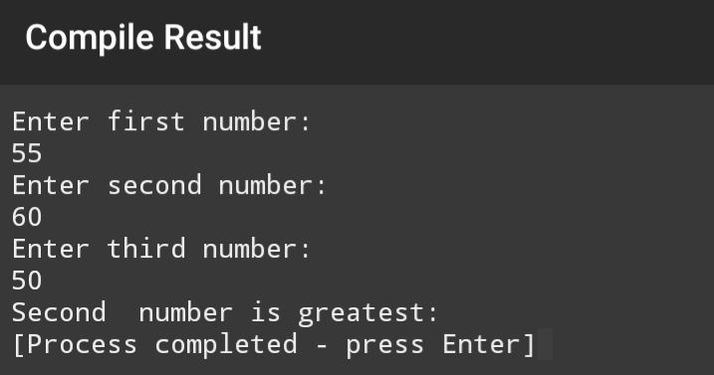

QUESTION 08(OUTPUT) 03

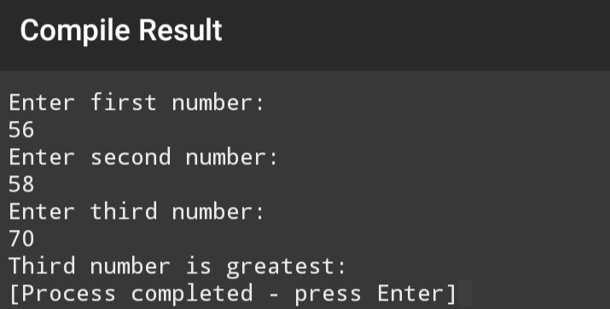

QUESTION 09(CODE)

#include<iostream>

using namespace std;

int main()

{

double a,b;

char operation;

cout << "Enter first number:\n";

cin>>a;

cout << "Enter second number:\n";

cin>>b;

cout<<"enter operator"<<endl;

cin>>operation;

if(operation=='+')

cout<<"operation was + and result is "<<a+b<<endl;

if(operation=='-')

cout<<"operation was - and result is "<<a-b<<endl;

if(operation=='*')

cout<<"operation was * and result is "<<a*b<<endl;

if(operation=='/')

cout<<"operation was / and result is "<<a/b<<endl;

return 0;

}

QUESTION 9(OUTPUT) 01

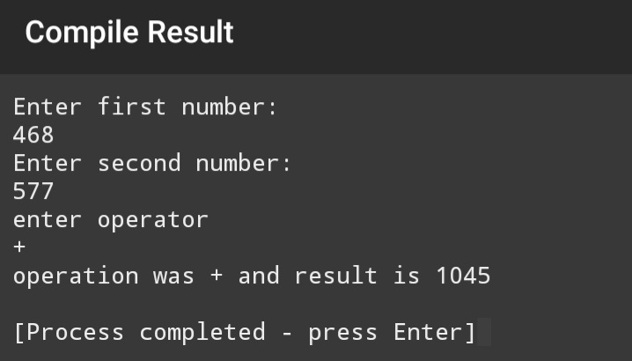

QUESTION 09(OUTPUT) 02

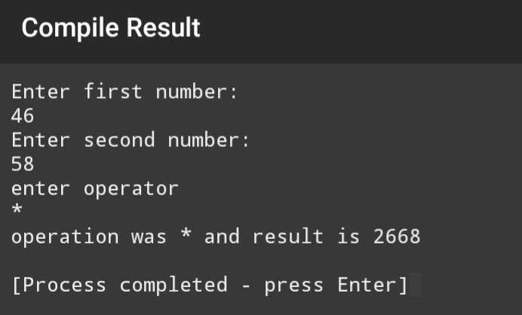

QUESTION 09(OUTPUT) 03

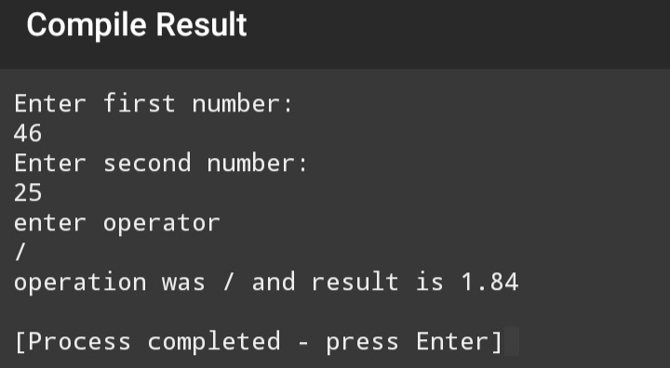

QUESTION 10(CODE)

#include <iostream>

#include<string>

using namespace std;

int main ()

{ string name;

int ID;

int units;

int total_amount;

cout<<"Write your name:\n";

getline(cin,name);

cout<<"Write your ID number:\n";

cin>>ID;

cout<<"Write number of units:\n";

cin>>units;

if(units>=1&&units<=199)

{

total_amount=units*5;

cout<<"Your total amount is:"<<total_amount<<endl;}

else if(units>=200&&units<=399)

{total_amount=units*10;

cout<<"Your total amount is:"<<total_amount<<endl;}

else if(units>=400&&units<=599)

{total_amount=units*15;

cout<<"Your total amount is:"<<total_amount<<endl;}

else if(units>=600)

{total_amount=units*20;

cout<<"Your total amount is:"<<total_amount<<endl;}

else if(units<0)

{cout<<"Invalid input!";}

return 0 ; }

QUESTION 10(OUTPUT) 01

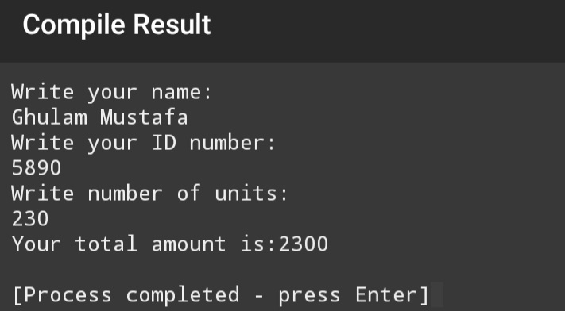

QUESTION 10(OUTPUT) 02

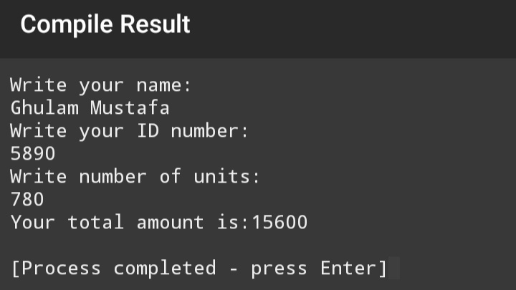

QUESTION 10(OUTPUT) 03

